**Formatted Output**

Formatting is accomplished by manippulating the output stream. Must #include <iomanip> in order to use these.

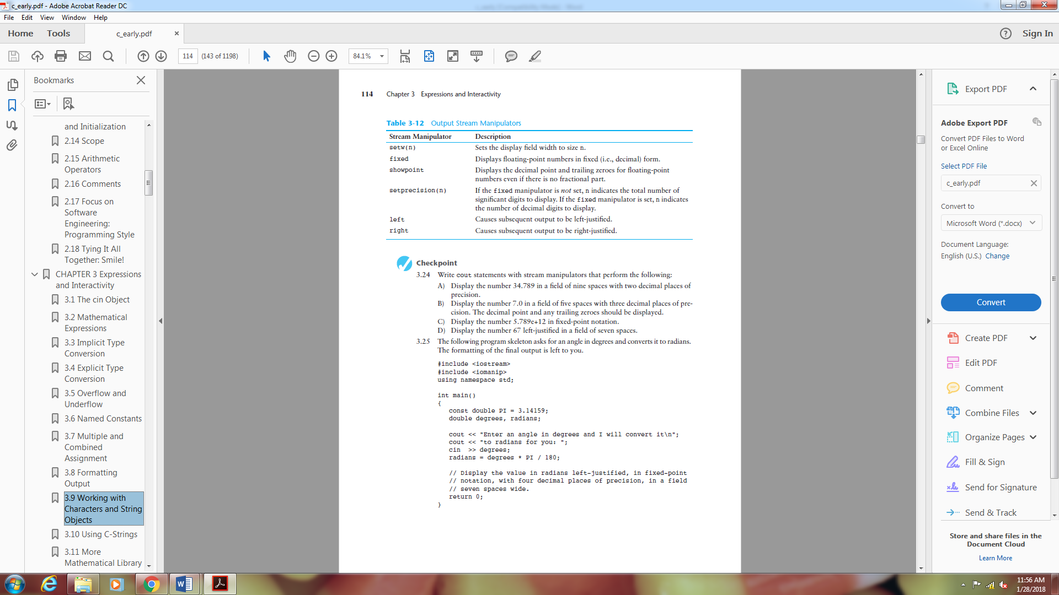

**The setw manipulator**

// This program uses setw to display three rows of numbers so they align.

#include <iostream>

#include <iomanip> // Header file needed to use setw

using namespace std;

int main()

{

int num1 = 2897, num2 = 5, num3 = 837,

num4 = 34, num5 = 7, num6 = 1623,

num7 = 390, num8 = 3456, num9 = 12;

// Display the first row of numbers

cout << setw(6) << num1 << setw(6) << num2 << setw(6) << num3 << endl;

// Display the second row of numbers

cout << setw(6) << num4 << setw(6) << num5 << setw(6) << num6 << endl;

// Display the third row of numbers

cout << setw(6) << num7 << setw(6) << num8 << setw(6) << num9 << endl;

return 0;

}

**Program Output**

2897 5 837

34 7 1623

390 3456 12

**The setprecision Manipulator**

// This program asks for sales figures for three days.

// The total sales are calculated and displayed in a table.

*#*include <iostream>

*#*include <iomanip>

using namespace std;

int main()

{

double day1, day2, day3, total;

// Get the sales for each day

cout << "Enter the sales for day 1: ";

cin >> day1;

cout << "Enter the sales for day 2: ";

cin >> day2;

cout << "Enter the sales for day 3: ";

cin >> day3;

// Calculate total sales

total = day1 + day2 + day3;

// Display the sales figures

cout << "\nSales Figures\n";

cout << "-------------\n";

cout << setprecision(5);

cout << "Day 1: " << setw(8) << day1 << endl;

cout << "Day 2: " << setw(8) << day2 << endl;

cout << "Day 3: " << setw(8) << day3 << endl;

cout << "Total: " << setw(8) << total << endl;

return 0;

}

**Program Output with Example Input Shown in Bold**

Enter the sales for day 1: **321.57[Enter]**

Enter the sales for day 2: **269.60[Enter]**

Enter the sales for day 3: **307.00[Enter]**

Sales Figures

-------------

Day 1: 321.57

Day 2: 269.6

Day 3: 307

Total: 898.17

**The fixed Manipulator**

What is perhaps most important about the fixed manipulator, however, is that when the

setprecision manipulator is used in conjunction with fixed, it behaves in a new way. It

specifies the number of digits to be displayed after the decimal point of a floating-point

number, rather than the total number of digits to be displayed. This is usually what we

want.

// This program asks for sales figures for three days.

// The total sales are calculated and displayed in a table.

*#*include <iostream>

*#*include <iomanip>

using namespace std;

int main()

{

double day1, day2, day3, total;

// Get the sales for each day

cout << "Enter the sales for day 1: ";

cin >> day1;

cout << "Enter the sales for day 2: ";

cin >> day2;

cout << "Enter the sales for day 3: ";

cin >> day3;

// Calculate total sales

total = day1 + day2 + day3;

// Display the sales figures

cout << "\nSales Figures\n";

cout << "-------------\n";

cout << fixed << setprecision(2);

cout << "Day 1: " << setw(8) << day1 << endl;

cout << "Day 2: " << setw(8) << day2 << endl;

cout << "Day 3: " << setw(8) << day3 << endl;

cout << "Total: " << setw(8) << total << endl;

return 0;

}

Enter the sales for day 1: **321.57[Enter]**

Enter the sales for day 2: **269.60[Enter]**

Enter the sales for day 3: **307.00[Enter]**

Sales Figures

-------------

Day 1: 321.57

Day 2: 269.60

Day 3: 307.00

Total: 898.17

**The showpoint Manipulator**

// This program illustrates how the fixed, showpoint, and

// setprecision manipulators operate when used together.

*#*include <iostream>

*#*include <iomanip> // Needed to use stream manipulators

using namespace std;

int main()

{

double amount = 125.0;

cout << setw(6) << amount << endl;

cout << showpoint;

cout << setw(6) << amount << endl;

cout << fixed << showpoint << setprecision(2);

cout << setw(6) << amount << endl;

return 0;

}

**Program Output**

125

125.000

125.00